7.1 Introduction
The server application work on asynchronous sockets while accepts multiple clients, this help increase performance of service. Fig (7.1) shows the server flow chart.
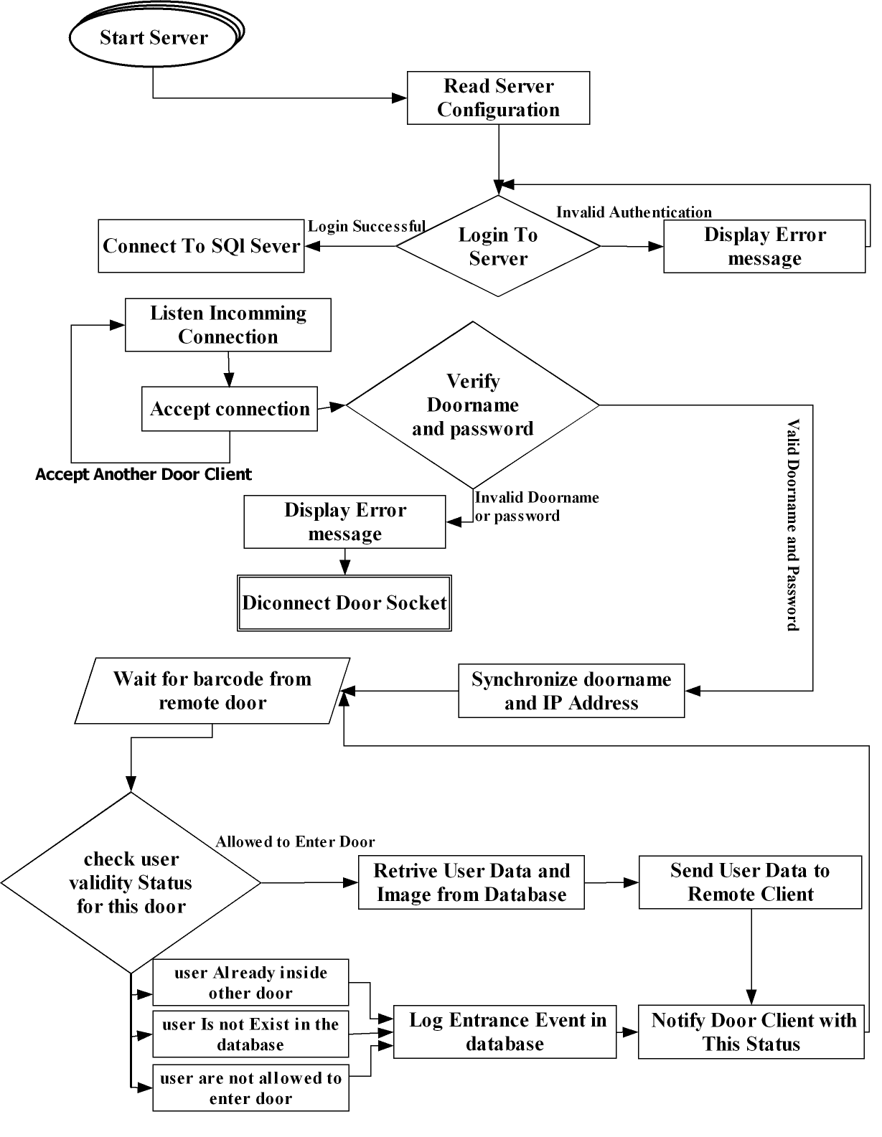
Figure (7.1): Server Flow Chart

7.2 Server Application Capabilities
The following subsection provides full description to server capabilities and how to deal with it.

7.2.1 Secured Login Page
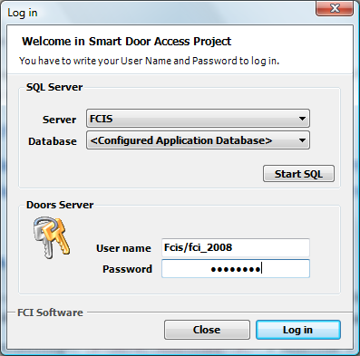
Application have robust secured login page with capability of start automatically SQL Server Service Locally, this appear in Fig (7.2)

Figure (7.2): show login form of application.
If user enters incorrect user name/password, message in Fig (7.3) will appear
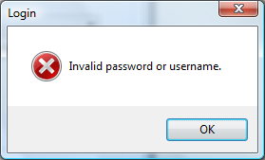

Figure (7.3): show message boxes when user enters invalid information.

7.2.2 Attractive GUI Design
Application GUI Fig (7.4) appears to have a status bar that contains:
- Server Status: connected or not.
- Database status: this info tell us whether server is connected to database or not.
- Doors Online: show number of Doors online.
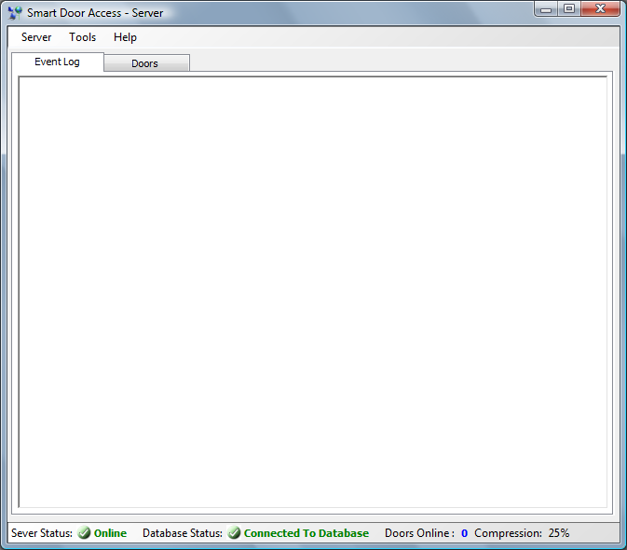
- Compression ratio: this value used in monitor capability which specify compression percent of pictures received from client, this allow for fast retrieval of information.
Figure (7.4): Show main form of server application.
7.2.3 Application Menu
As shown in Fig (7.5)
Server Menu item: it has 4 menu items which include
- Disconnect server: which disconnect server socket so drop all clients found in doors list tab.
- Close database Connection: this menu item allows you to close local database connection.
- Restart server: this button allow you to restart server application.
- Exit: allow you to close server application.
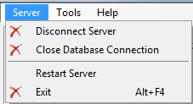

Figure (7.5): show server menu that contain mandatory items.
Tools Menu Item Fig (7.6):
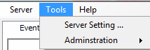

Figure (7.6) The tools menu which contain program and user configuration.
- Server setting: this menu item will show configuration form that contain server configuration to modify.
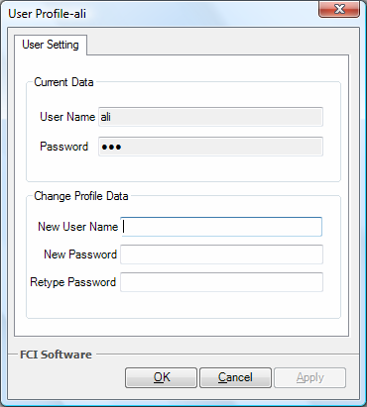
- Administration: this menu item allows server administration employees to change their passwords as shown in Fig (7.7).

Figure (7.7): shows the form that allows user to change user name and password.

Help Menu item Fig (7.8):
- Help Topics: this menu item opens application help file (help.chm) that contains help topics of the application.
- About us: this menu item show form contains Application development team information.
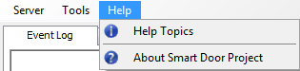

Figure (7.8): show help menu items
7.2.4 Easy & Smart Configuration setting
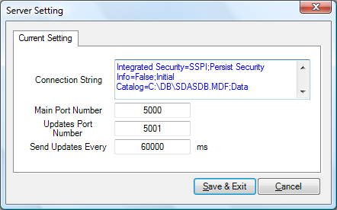
It provides users with easy way configuration, containing all needed information for running application correctly as shown in Fig (7.9).

Figure (7.9): show server configuration (connection String, connection port, etc).

7.3 Data packaging
This section will explain the form of the transmission of data between client door and server door and how the server can identify the meaning of the request (i.e.
mClient.SendMessage( "[#<CMD>#][#Barcode#][#]1620040008300[#]LAB_3_A[#]1[#]");
This tells the server that to send information about this barcode. So server will know the meaning by reading this line of code and parse it in an array and separate "[#]"ing away. After the server understand the request it check if it barcode exist or not. If it exist it send the required information to the client it also send whether this barcode number are authorized or not.
7.4 Data Compression
In the project we will use the compression for images that we will transfer between client and server so we will introduce an idea about it.
The goal of data compression is to represent an information source (e.g. a data file, a speech signal, an image, or a video signal) as accurately as possible using the fewest number of bits than an unencoded representation would use through use of specific encoding schemas. one popular instance of compression with which many computer users are familiar is the ZIP file format, which ,as well as providing compression ,acts as an archive, storing many source files in a single destination output file.

7.4.1 There are two types of compression
Lossless compression algorithms usually exploit statistical redundancy in such a way as to represent the sender's data more concisely without error, Lossless compression is possible because most real-world data has statistical Redundancy. For example, in English text, the letter 'e' is much more common than The letter 'z' and the probability that the letter 'q' will be followed by the letter 'z' is very small.
- Lossy data compression or perceptual, is possible if some loss of fidelity is acceptable. JPEG image compression works in part by "rounding off" some of this less-important. Lossy data compression provides a way to obtain the best fidelity for a given amount of compression and this technique we use in the application as network resources are costly.
- Lossless compression schemes are reversible so that the original data can be reconstructed, while lossy schemes accept some loss of data in order to achieve higher compression.
Image compression is an application of Data compression on digital images. In
Effect, the objective is to reduce redundancy of the image data In order to be able to
Store or transmit data in an efficient form. In the project we use this
Technique (compression of image) by only adjust the quality from range (0---→100).
7.4.2 Methods for lossless image compression
- Run-length encoding – used as default method in PCX and as one of Possible in BMP, TGA, TIFF.
- Entropy code.
- Adaptive dictionary algorithms such as LZW – used in GIF and TIFF.
- Deflation– used in PNG, MNG and TIFF.

7.4.3 Methods for lossy compression
- Reducing the color space to the most common colors in the image. The
Selected colors are specified in the color palette in the header of the compressed image. Each pixel just references the index of a color in
- The color palette. This method can be combined with dithering to avoid posterization.
- Chrome sub sampling. This takes advantage of the fact that the eye perceives brightness more sharply than color (eye is less sensitive to image info than brightness of image), by dropping half or more of the chrominance (illuminace) information in the image.
- Transform coding. This is the most commonly used method. A Fourier-related transform such as DCT or the wavelet transform are applied, followed by quantization and entropy coding.

The best image quality at a given bit-rate (or compression rate) is the main goal of Image compression, and .net have really appreciated classes used to achieve quality compression of images such as System.Drawing.Imaging.Encoder class

7.5 Event Log User interface
Fig (7.10) show application event log which contain info about which barcode numbers received from client, whether client connected or disconnected, whether barcode number are allowed to enter or restricted to specific door.
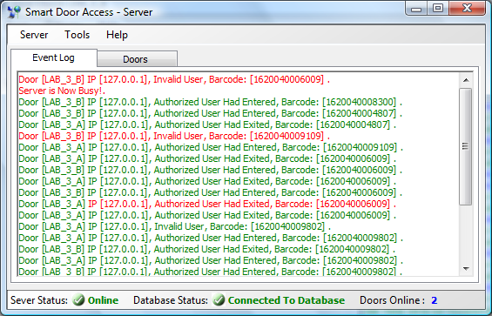 Figure (7.10): show event log form which contain current events occur

7.6 Connected Doors Tab
This tab will show icons for each online door that connect to server, this icons can be used to communicate with each client (each one in separate form) , communication will be in form of (show client details, monitor client desktop, disconnect client socket, and more …) this can be show in fig. 7.11
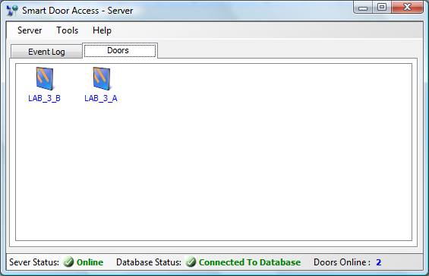
Figure (7.11): show Current online doors connected to server as icons
7.7 Clients action menu
This menu as explained below and shown in Fig(7.12) used to communicate with online clients triggering them to execute specific actions such as send its information to server, send desktop images to server so server will support remote connection and control.

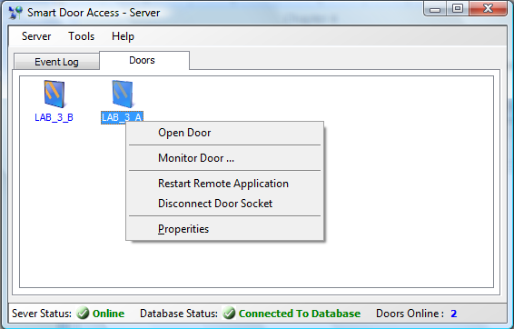
Figure (7.12): show client action menu so we can monitor door or open door remotely.

7.8 Monitor client desktop remotely
This is an extra creative part in the server application that is used to monitor remote door machine desktop it previews life video of what happens there also it enables controlling remote machine.
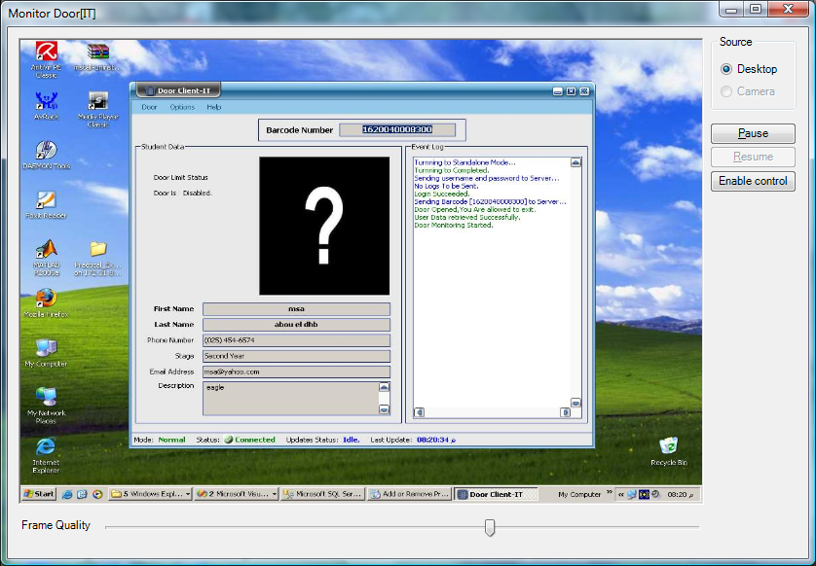
Figure (7.13): show how server monitors one of clients desktop (here the client with xp os, and server with Vista os).

